Minerals
Mineral Properties
Mineral Tests

What are minerals?

- ________________: common Earth materials that are important to our everyday lives & the ________________________________.

*You must know how to use ESRT pages 16 & 17: Mineral Identification Flowchart

- What are the characteristics of a mineral?

- Minerals are:

- ________: not liquid or gas

- inorganic: ________________/never were living/not created by a living thing

- naturally occurring: ________________________________

- composed of ________________ or ________________: not a mixture

- made of ________________________________________ or molecules. Many minerals occur as crystals and have a _____________________________________.

2. How are the physical properties of minerals determined?

- Physical properties are due to the ________________________________________________.

- Common Example: Graphite & diamond are 100% carbon. Since the carbon atoms are arranged in a different manner, they have very different properties:
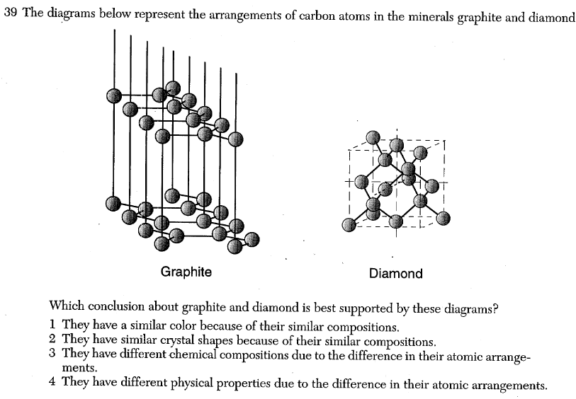

Graphite | Property | Diamond
Flat sheets | Atom Arrangement | Crystalline structure
Very soft | Hardness | Hardest natural substance
Silver-gray | Color | Transparent
Pencil lead | Uses | Jewelry

3. How can we differentiate between minerals?
Properties of Minerals
Color | - Easy to recognize, but _______________________.  - Example 1: Minerals can come in several colors (ex: quartz can be white, pink, and grey)  - Example 2: Different minerals can be the same color (ex: Calcite and halite are both colorless.)
Streak | - ________________________________________________  - Even if a mineral comes in several colors, the streak will always be the same.  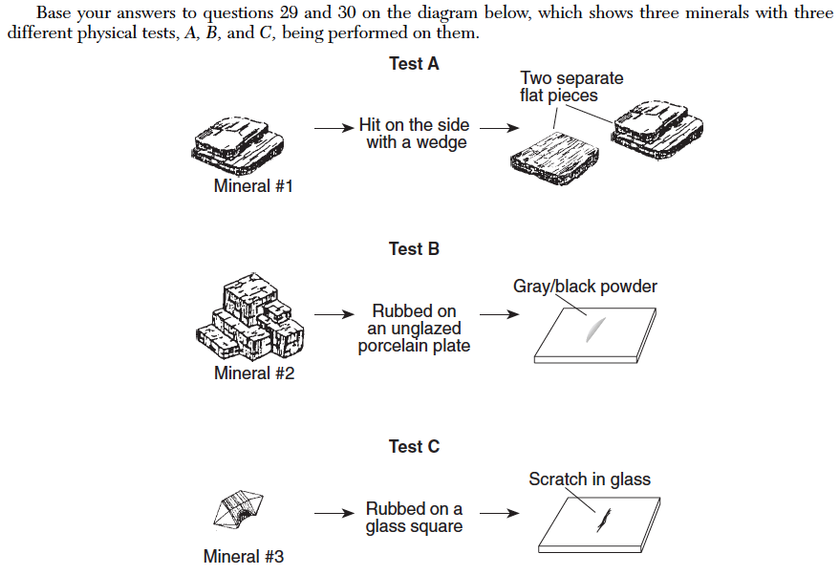
Luster | - The way a mineral reflects light…  - ______________: looks like shiny metal  - ________________: does not look like a shiny metal
Hardness | - A minerals ability to scratch or be scratched (use Moh’s Hardness Scale)  - Scratch test: Harder minerals can scratch softer minerals    Glass hardness  = 5.5
Breakage Pattern | - ________________: Tendency for a mineral to split along a smooth, ________________________________    - ________________: Tendency for a mineral to break into pieces with ________________________________
Acid Test | 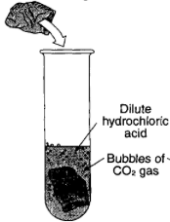  - Calcite bubbles with acid  - This is a chemical property
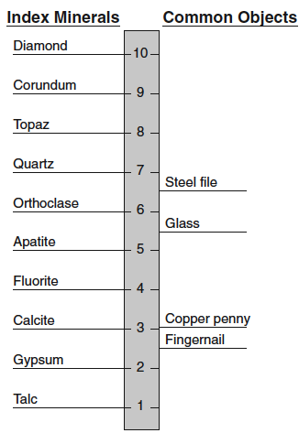
- Moh’s Scale of Hardness: ten minerals whose hardness have been identified on a scale from 1 to 10 (1 is the softest and 10 is the hardest).

- Checkpoint - Properties of Minerals: Using the clues provided and ESRT page 16, determine the identity of the mineral described.

- I have metallic luster and I am used as an ore for sulfur; often known as fool’s gold.
- I have the lowest hardness on Moh’s scale, greasy feel, and used in ceramics.
- I am colorless to white and I’m used as a food additive usually with pepper.
- I’m dark and I break in thin flexible sheets and often used in construction materials.
- I’m black to silver and I am attracted to a magnet.
- I’m colorless, I bubble with acid, and often used in cement and lime.
- I’m also colorless and my powdered form bubbles with acid.
- I am a common hard mineral used in ceramics and glass and I contain the element K.
- I’m usually dark red and found in many New York State Metamorphic rocks.
- I’m very easily scratched and I’m found in the drywalls of your house.
- I’m commonly light green and granular and often made into jewelry.
- I am often bright yellow and I’m used in sulfuric acid.
- I can have either metallic or nonmetallic luster and used as an ore for iron.
- I’m made entirely of carbon and found in your pencil.
- I’m metallic silver, very dense, and an ore of lead.
- BONUS: I’m made entirely of carbon and used in drill bits, earrings, and no other mineral besides myself can scratch me.

